Challenge-03
Installing services in AWS EC2 instance
- Launch oneEC2 instance using Amazon Linux 2.

1. Login to AWS Management Console as a root user.
2. Navigate to EC2 and click Launch Instance.
3. Name the instance (e.g., My_services).
4. We choose the instance type (For running all these services
simultaneously, t3.medium or higher is highly recommended
5. we select the already created Key Pair, linux_testing.pem for SSH access.
6. Under Network Settings, configure your Security Group inbound rules
To allow all traffic

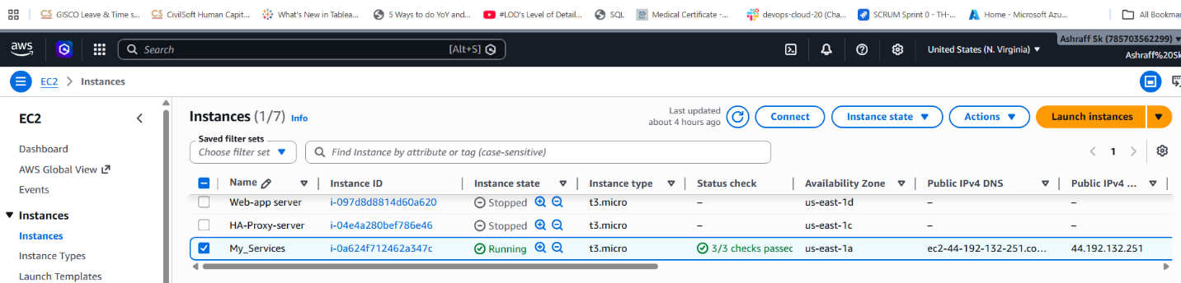

- Install Docker

Steps:

  - Connect to AWS EC2 instance
Ssh -i key_pair user@ipv4
Switch to root user, sudo su -

  - Update the package
sudo yum update -y

  - Install Docker:
sudo yum install -y docker

  - Start the service:
sudo service docker start
sudo systemctl enable docker

  - check the status service:
sudo systemctl status docker
  - Grant permissions
sudo usermod -a -G docker ec2-user

  - Verify the Installation
Docker run hello-world

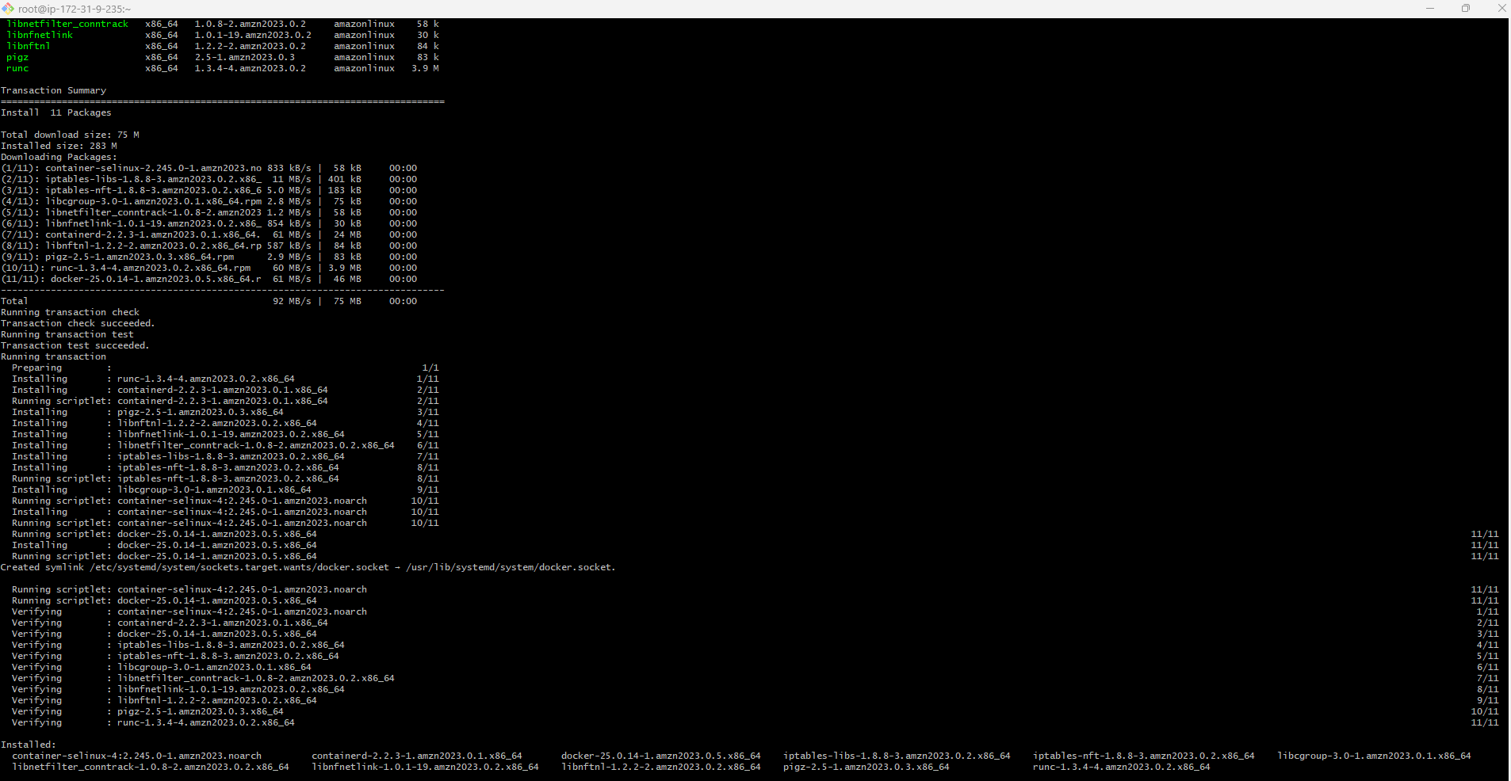

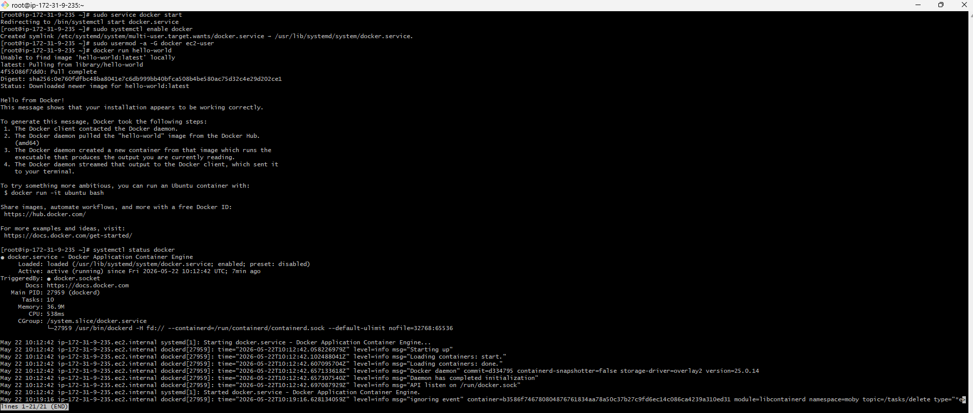

- Install Jenkins.

  - Connect to AWS EC2 instance
Ssh -i key_pair user@ipv4
  - Pre-requisite:
Java: Sudo yum install java-21 -y
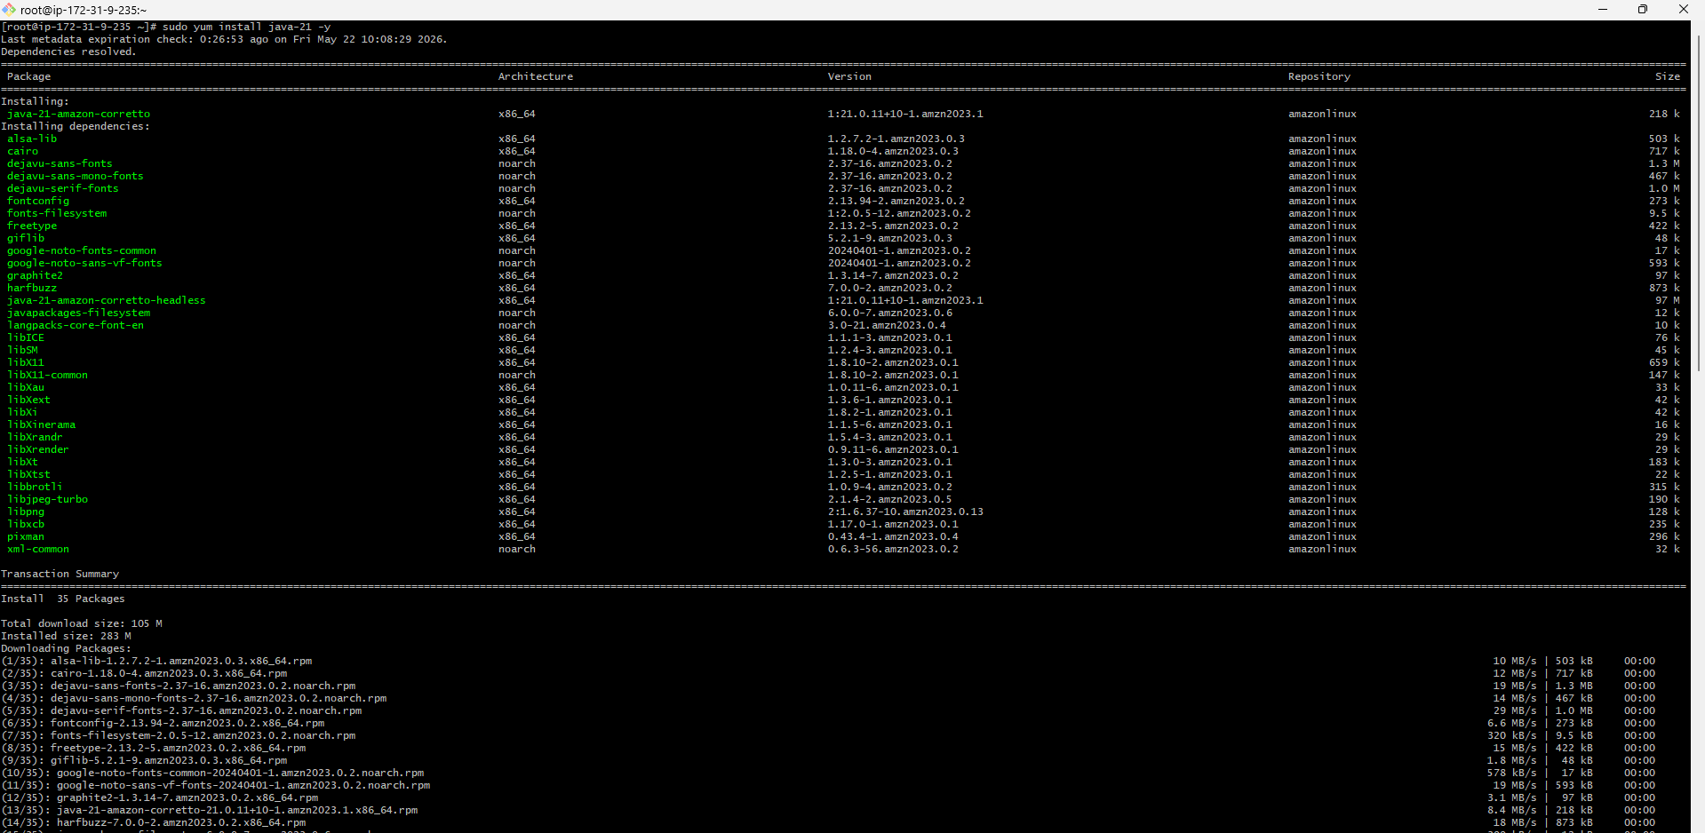

  - Install Jenkins:
Sudo yum install Jenkins -y

Error: no match for arguments:Jenkins
We need to add Jenkins repository by
wget wget -O /etc/yum.repos.d/jenkins.repo \
https://pkg.jenkins.io/redhat-stable/jenkins.repo
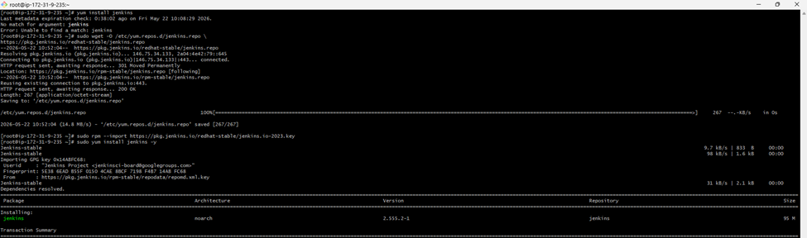
  - Import Jenkins Key
rpm --import https://pkg.jenkins.io/redhat-stable/jenkins.io-
2023.key

  - Install Jenkins:
sudo yum install jenkins -y

  - Start Jenkins:
systemctl start Jenkins

  - Check Status:
systemctl status jenkins

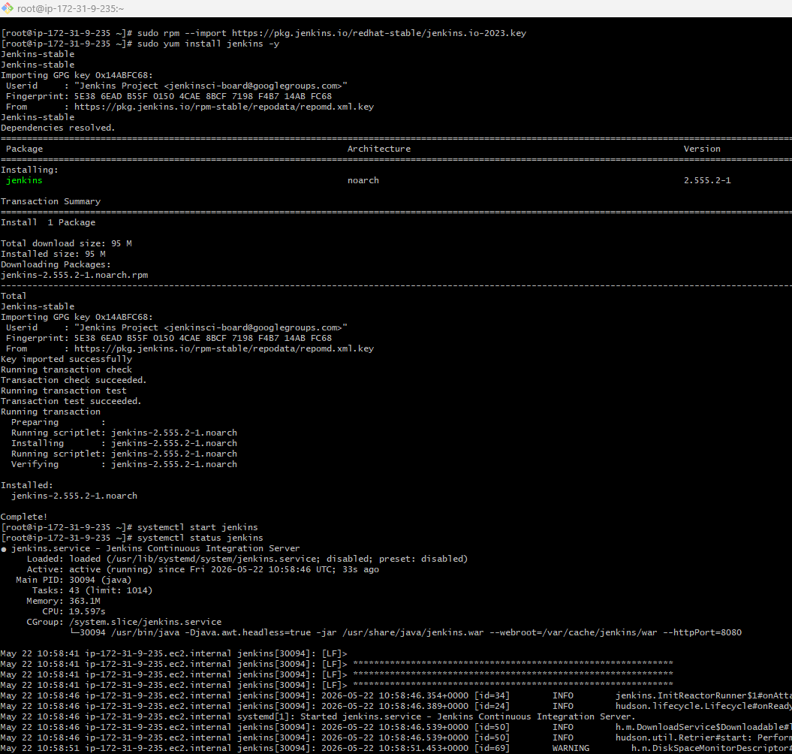

  - Access Jenkins:
http://<EC2-PUBLIC-IP>:8080

  - Get Initial Password:
cat /var/lib/jenkins/secrets/initialAdminPassword

  - Verify Repository Added Properly:
cat /etc/yum.repos.d/jenkins.repo

Install suggested plugins and create a account with credentials
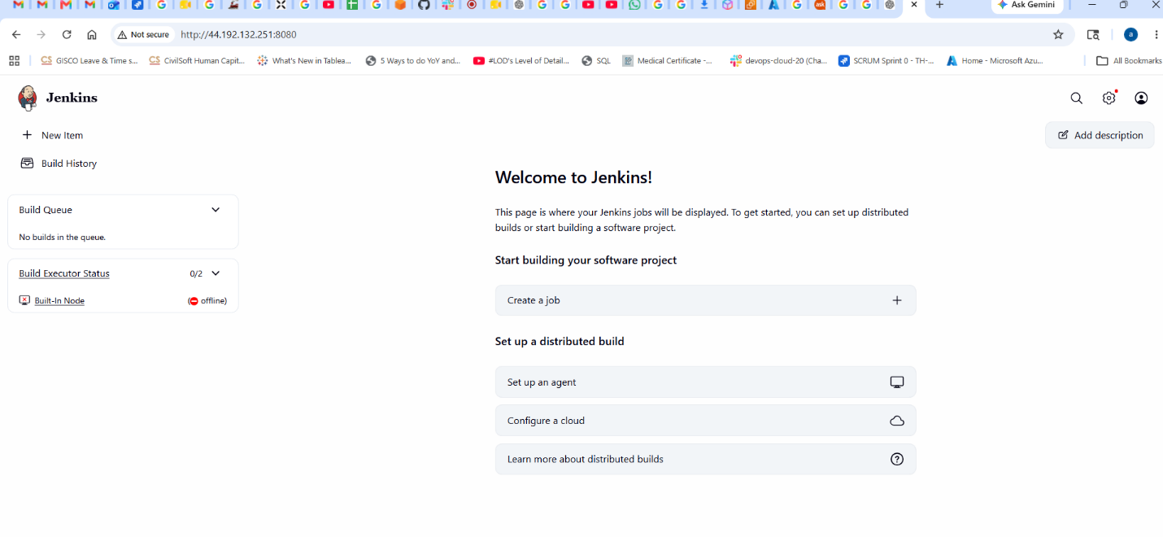

- Install Apache.

Steps:

  - Connect to AWS EC2 instance
ssh -i key_pair user@ipv4
Change to root user, sudo su –

  - Install apache (httpd):
sudo yum install httpd -y

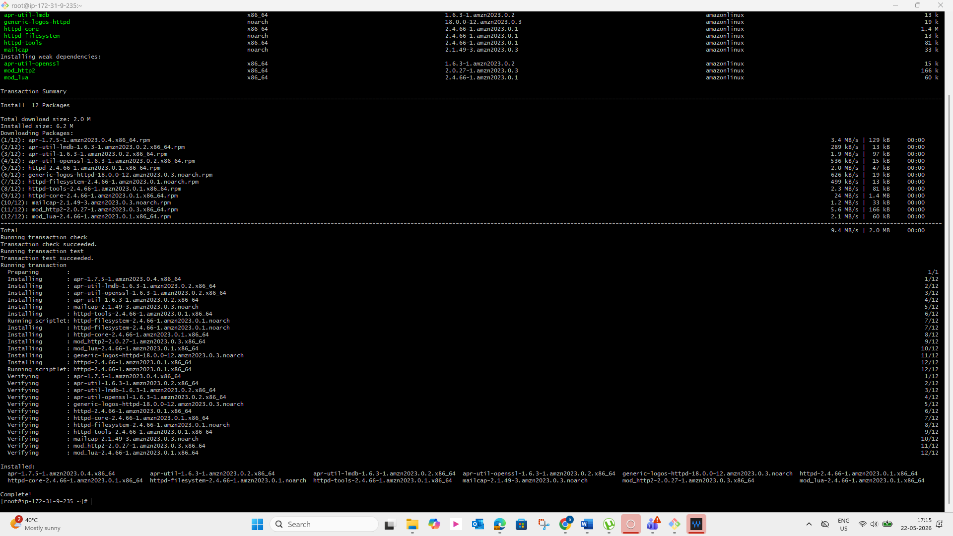

  - Start httpd:
systemctl start httpd

  - Check Status:
systemctl status httpd

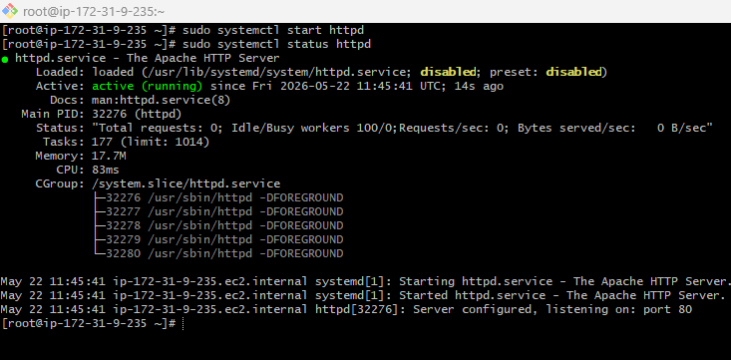

  - Stop Status:
systemctl stop httpd

  - Change port:
The configuration file httpd_conf to edit and make port as 81
Vi /etc/httpd/conf/httpd.conf
Make Listen as 81 instead of 80

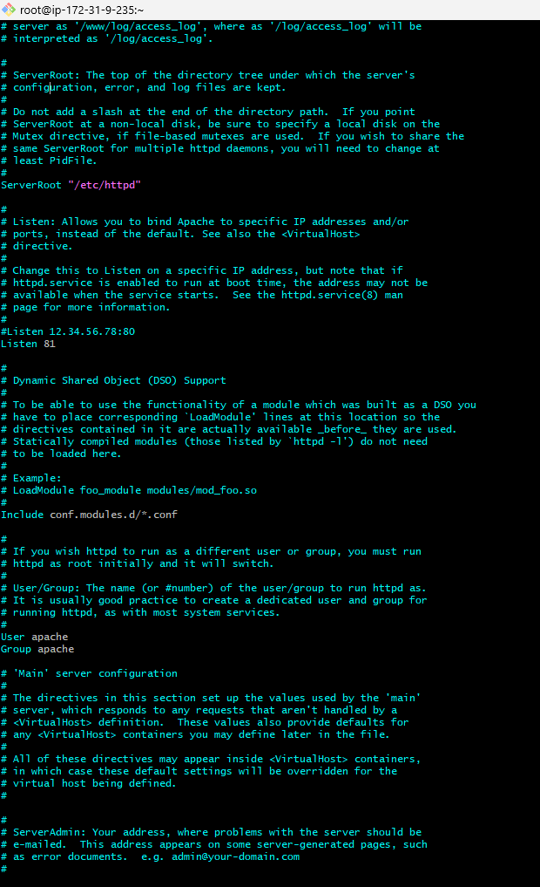

  - Systemd Service Files reload & start
Systemctl daemon-reload
Systemctl start httpd
Systemctl status httpd

  - Access httpd:
http://<EC2-PUBLIC-IP>:81

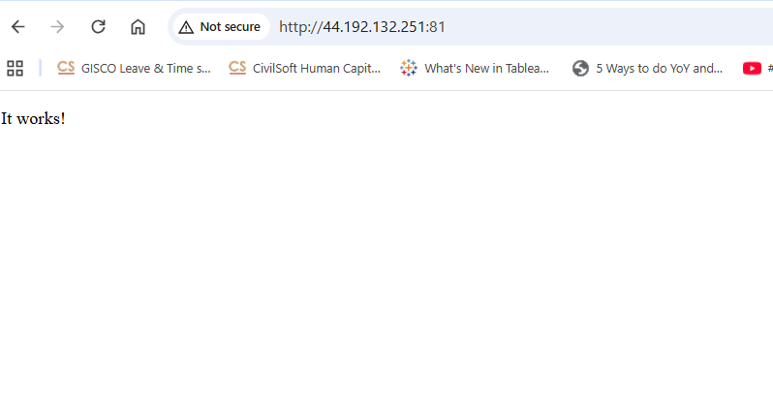

- Install Nginx.

Steps:
  - Connect to AWS EC2 instance
ssh -i key_pair user@ipv4
Change to root user, sudo su –

  - Install nginx :
sudo yum install nginx -y

  - Start nginx:
systemctl start nginx

  - Check Status:
systemctl status nginx

  - Stop Status:
systemctl stop nginx

  - Change port:
The configuration file nginx.conf to edit and make port as 81
vi /etc/nginx/nginx.conf
Make Listen as 82 instead of 80
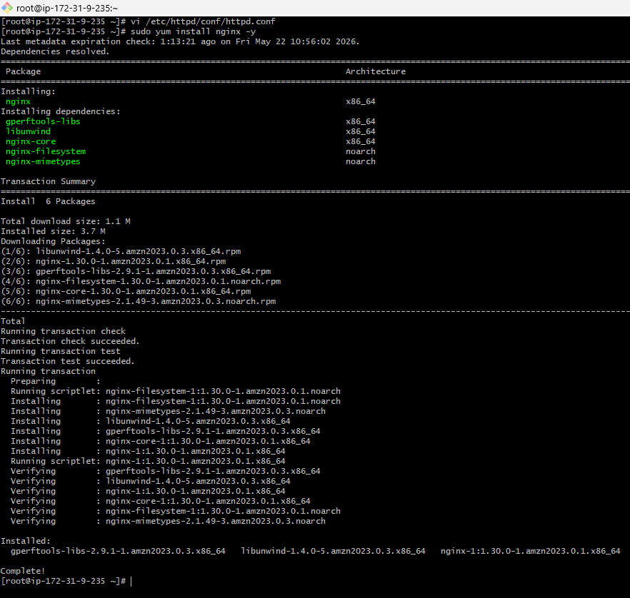
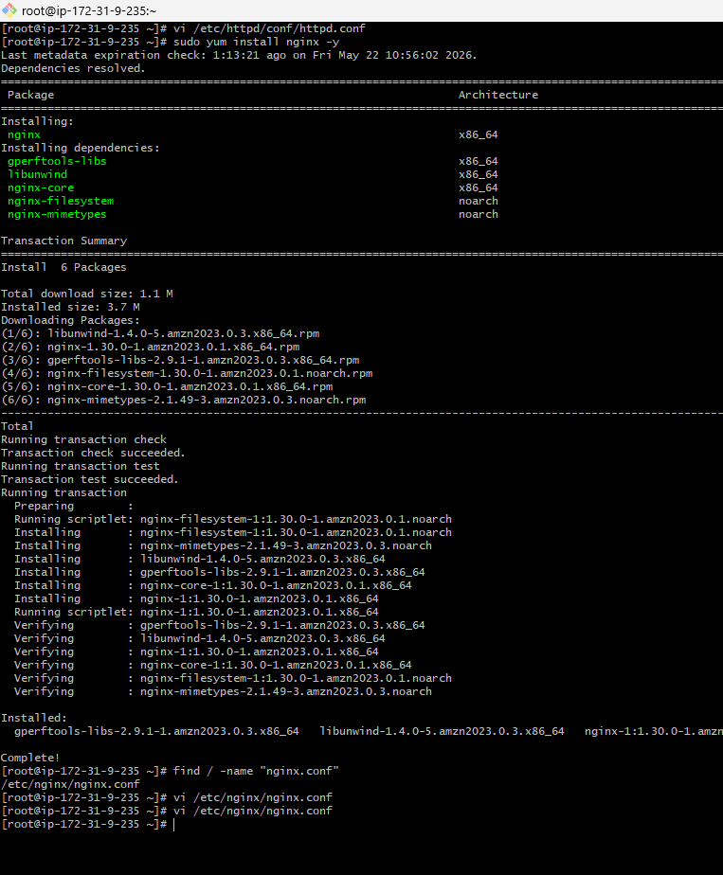
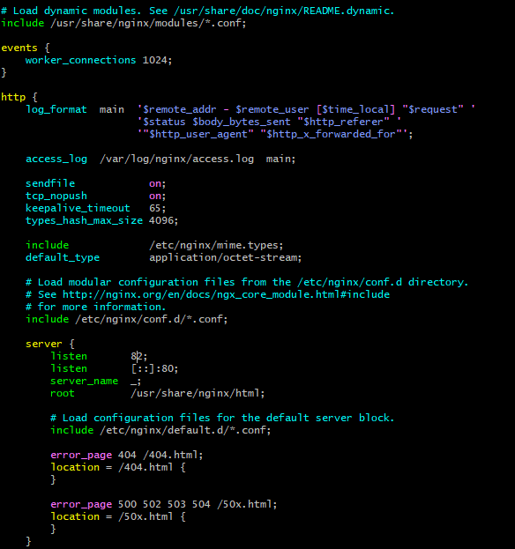
  - Systemd service files reload & start:
Systemctl daemon-reload
Systemctl start nginx
Systemctl status nginx
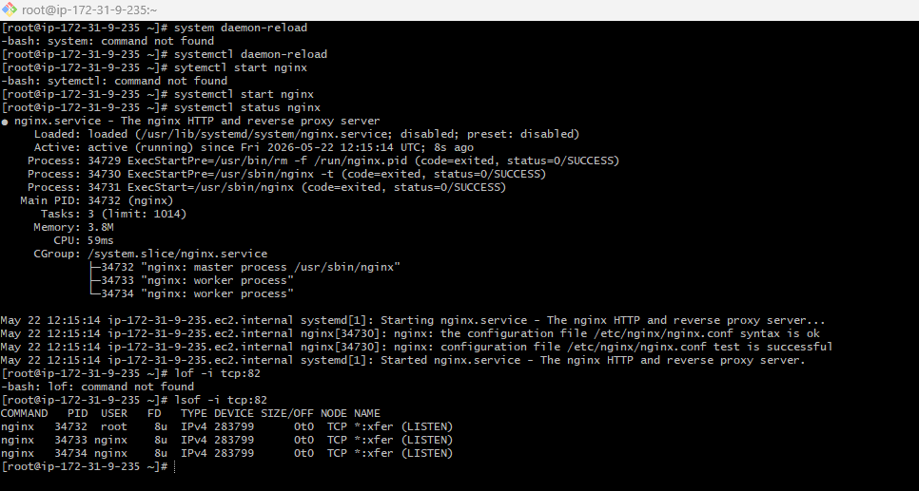

  - Access nginx:
http://<EC2-PUBLIC-IP>:82

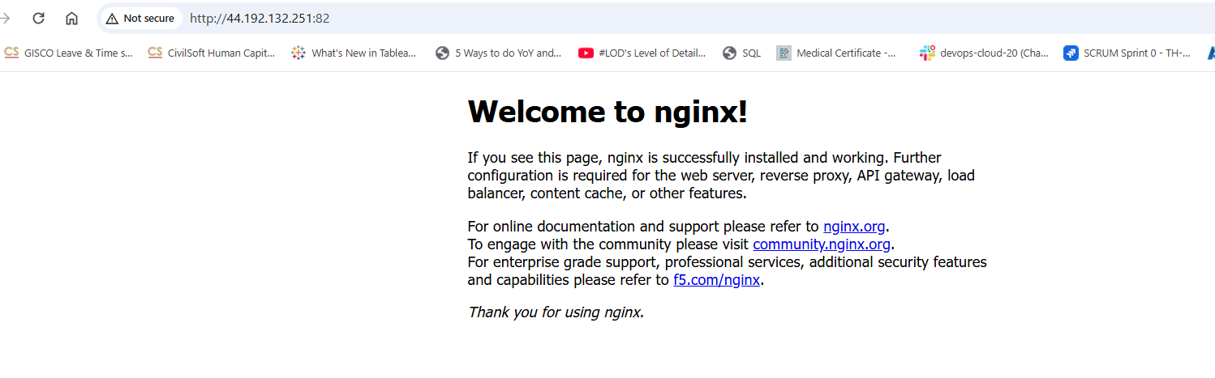
Conclusion:
Most web servers by default bind to the port 80 because
that is the global internet standard.

To avoid the conflict while building a multi-service development stack on a single server, we configured to port no: 81 and for nginx as port no:82

- Install Apache Tomcat.

Steps:

  - Connect to AWS EC2 instance
ssh -i key_pair user@ipv4
Change to root user, sudo su –

  - Pre-requisite:
Java: sudo yum install java-17 -y

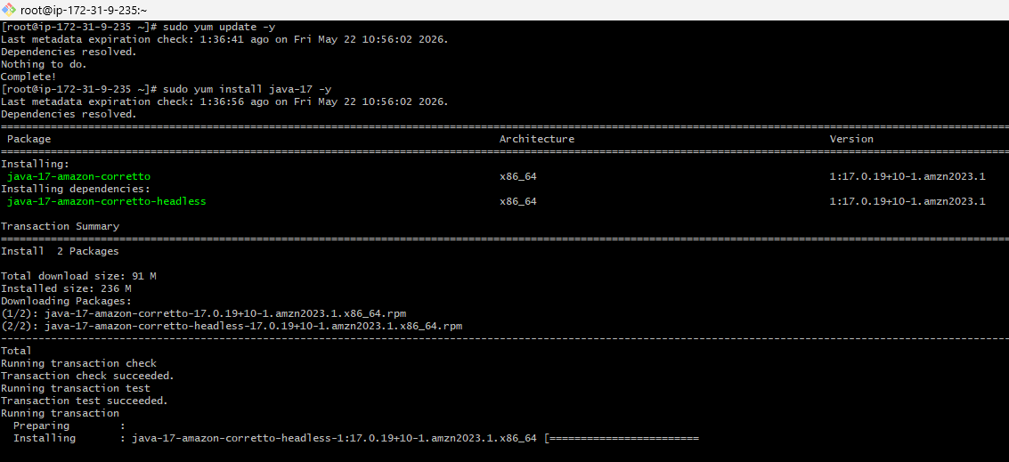

  - Download tomcat :
Cd /opt / wget https://dlcdn.apache.org/tomcat/tomcat-9/v9.0.118/bin/apache-tomcat-9.0.118.tar.gz
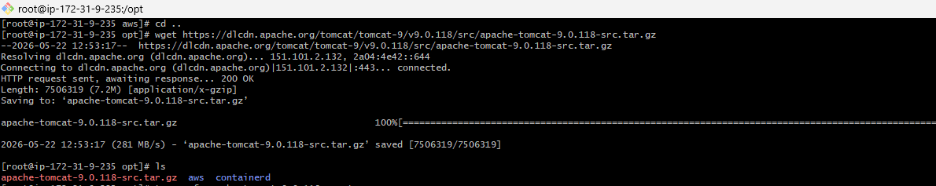
  - Extract & rename:
Cd /opt/ Tar -xvf <tomcat9 tar.gz>
Cd /opt/ mv apache-tomcat-9.0.118 tomcat

Open vi /etc/systemd/system/tomcat.service

Unit]
Description=Apache Tomcat Web Application Container
After=network.target
[Service]
Type=forking
Environment=JAVA_HOME=/usr/lib/jvm/java-17-amazon-corretto.x86_64
Environment=CATALINA_HOME=/opt/tomcat
Environment=CATALINA_BASE=/opt/tomcat
Environment=CATALINA_PID=/opt/tomcat/temp/tomcat.pid
ExecStart=/opt/tomcat/bin/catalina.sh start
ExecStop=/opt/tomcat/bin/catalina.sh stop
User=root
Group=root
Restart=always
[Install]
WantedBy=multi-user.target
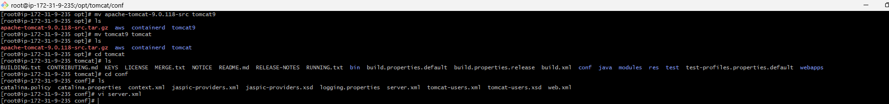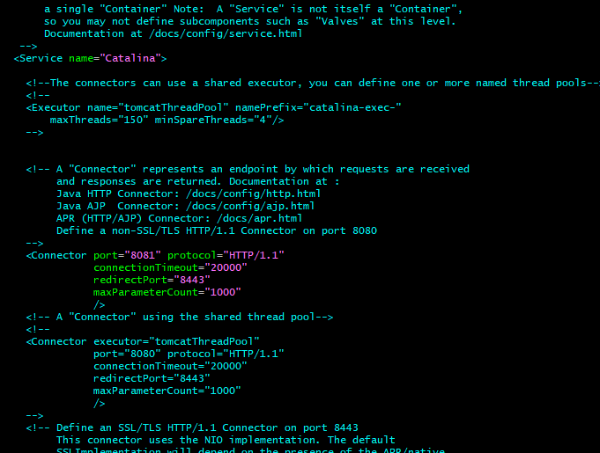
Provide executable permission to Chmod +x /opt/tomcat/bin/*.sh

  - Change port:
The configuration file server.xml to edit and make port as 8081
vi /opt/tomcat/server.xml
Connector Port as 8081 instead of 8080

  - Systemd service files reload & start:
Systemctl daemon-reload
Systemctl start tomcat.service
Systemctl status tomcat.service

  - Access tomcat9:
http://<EC2-PUBLIC-IP>:8081

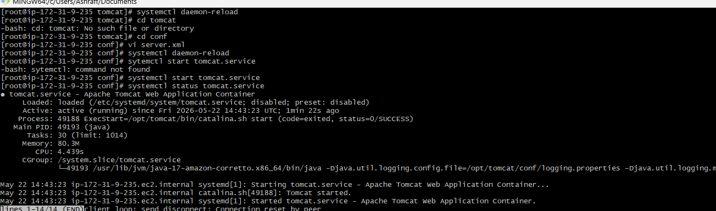
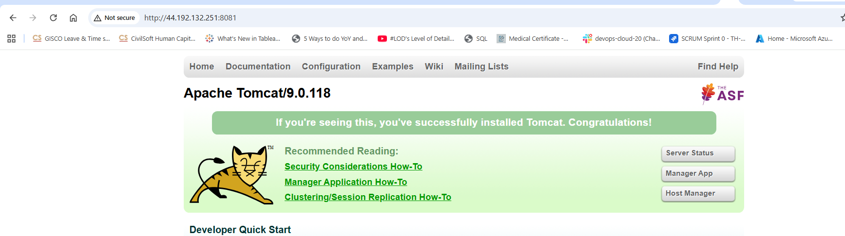

Errors: For Tomcat9 required is java-17 but by default java-21 is selected
resolved & rectified by shifting the default selection as java-17 by using the command, sudo update-alternatives --config java & selection as 2

